**Database Management Systems**

**PROJECT (DA1)**

**Driven Financial and Investment Management System**

**Faculty: Dr. Ilakiyaselvan N**

**SLOT: D2+TD2**

**Team Members**

Jayanthi Sharma – 22BCE1758

Riddhi Bandyopadhyay - 22BCE1068

Sinchan Shetty- 22BCE5238

**ER Diagram** 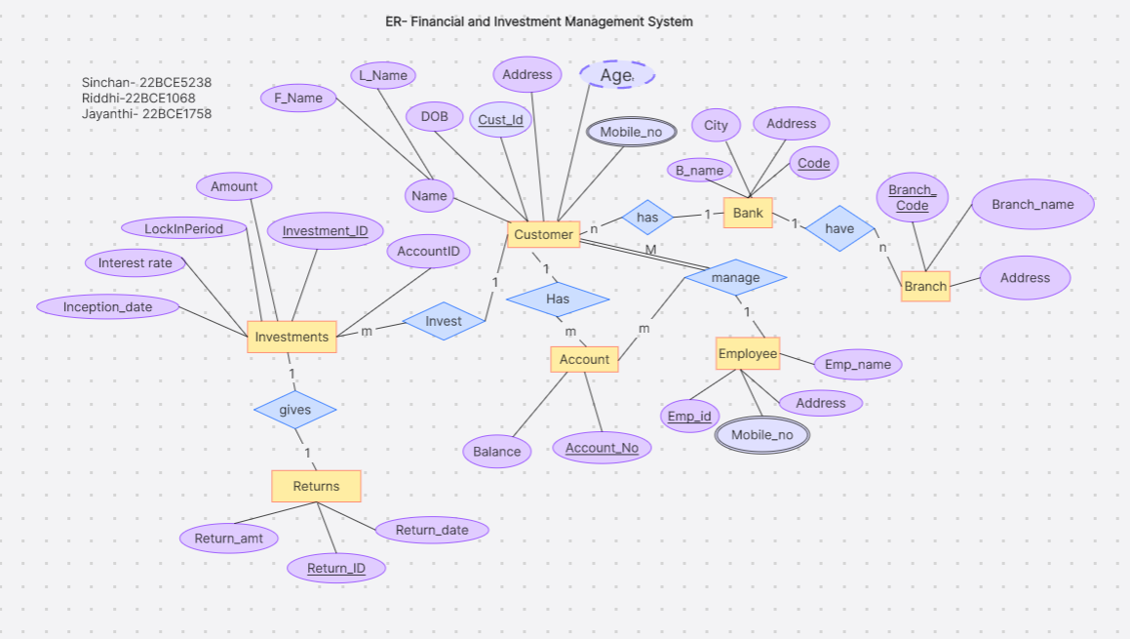

**EER DIAGRAM**

**Investments entity** is being specialised into 3 sub entities (Fixed Deposit, PPF, Mutual Funds).These sub entities are inheriting the attributes from the super-class(investments) and also have their own local attributes.

**Accounts entity** is being specialised into 2 sub entites (Saving, accounts) both consisting of inherited attributes.

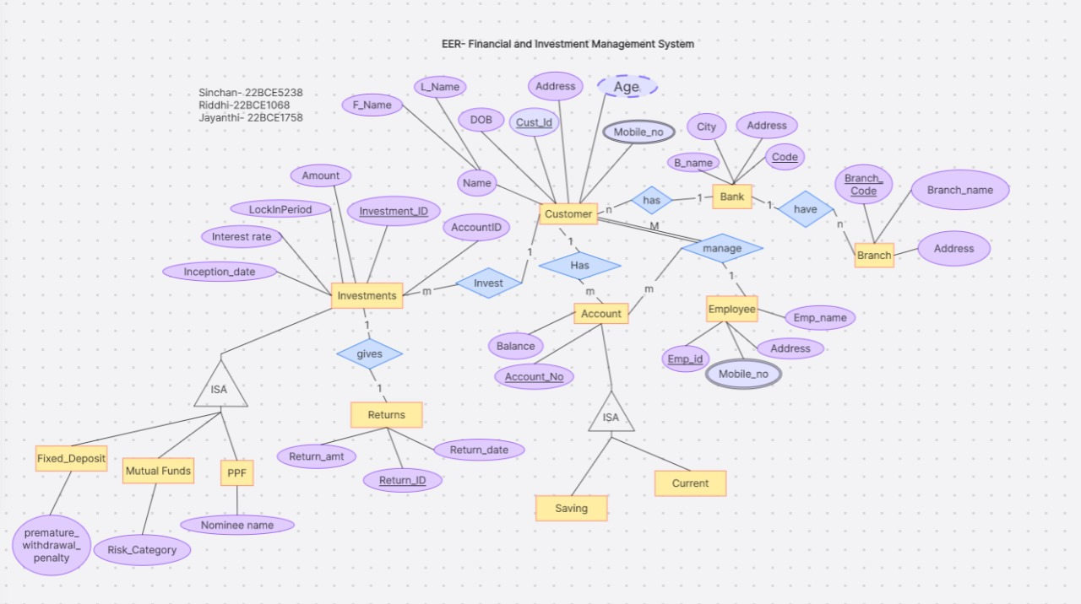

**DATA FLOW DIAGRAM**

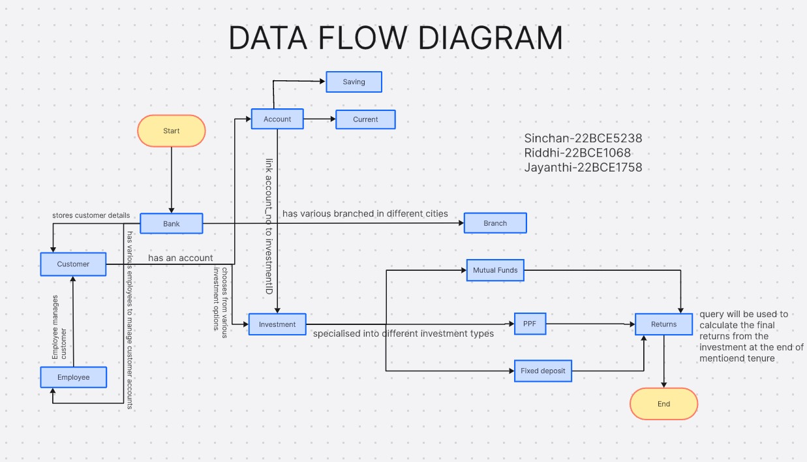

**High-level Diagram of Project Implementation**

